Chapter 19, Problem 51.

Obtain the t parameters for the network in Fig.19.105.
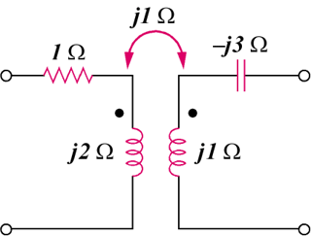

Figure 19.105
For Prob. 19.51.

